Git Cherry Pick

Scenario:
- You have two branches: branch-A and branch-B.
- You made a bug fix commit on branch-A that you now want to apply to branch-B without merging all changes from branch-A into branch-B.

Steps:
Identify the Commit:
First, find the commit hash of the bug fix commit on branch-A:
git log --oneline branch-A
- Suppose the commit hash is abcdef1234567890.
Switch to branch-B:
Ensure you are on branch-B where you want to apply the bug fix:
git checkout branch-B

Cherry-pick the Commit:
Apply the bug fix commit from branch-A to branch-B:
git cherry-pick abcdef1234567890
- This command applies the changes introduced by the commit abcdef1234567890 onto branch-B.
Resolve Conflicts (if any):
git cherry-pick --continue

Commit the Cherry-picked Changes:
After resolving conflicts (if any), commit the cherry-picked changes on branch-B:
git commit
- This creates a new commit on branch-B that includes the changes from branch-A's selected commit.
Git Stash

Step 1: Initialize a Git Repository
First, create a new directory for your project and initialize a Git repository:
mkdir git-stash-example
cd git-stash-example
git init

Step 2: Add and Commit Files
Create some files and add content to them:
echo "This is file1.txt" > file1.txt
echo "This is file2.txt" > file2.txt

Add these files to the staging area and commit them:
git add file1.txt file2.txt
git commit -m "Initial commit - Added file1.txt and file2.txt"

Step 3: Modify Files
Make some changes to file1.txt:
echo "Updated content in file1.txt" >> file1.txt

Step 4: Use git stash
Now, let's use git stash to temporarily store the changes in file1.txt without committing them:
git stash save "WIP: Work in progress changes"

This command saves your changes (in this case, the update to file1.txt) to a stash with a message "WIP: Work in progress changes".

Step 5: Verify Stash
You can verify the stash list using:

git stash list

It should show something like:
stash@{0}: On master: WIP: Work in progress changes

Step 6: Check Working Directory Status
Check the status of your working directory:
git status

It should indicate that your working directory is clean (no changes).

Step 7: Apply Stashed Changes
Let's apply the stashed changes back into your working directory:
git stash pop

Step 8: Verify Changes
Check the changes in file1.txt:

cat file1.txt

Step 9: Commit Stashed Changes
If you are satisfied with the changes, commit them:

git add file1.txt
git commit -m "Updated file1.txt with stashed changes"

Docker Project 01

Project Overview
In this project, you'll go through all three lifecycles of Docker: pulling an image and creating a container, modifying the container and creating a new image, and finally, creating a Dockerfile to build and deploy a web application.

Part 1: Creating a Container from a Pulled Image
Objective: Pull the official Nginx image from Docker Hub and run it as a container.
Steps:
Pull the Nginx Image:
docker pull nginx

Run the Nginx Container:
docker run --name my-nginx -d -p 8080:80 nginx

  - --name my-nginx: Assigns a name to the container.
  - -d: Runs the container in detached mode.
  - -p 8080:80: Maps port 8080 on your host to port 80 in the container.
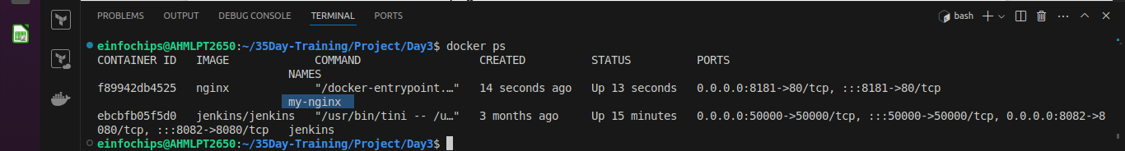
Verify the Container is Running:
docker ps

  - Visit http://localhost:8080 in your browser. You should see the Nginx welcome page.
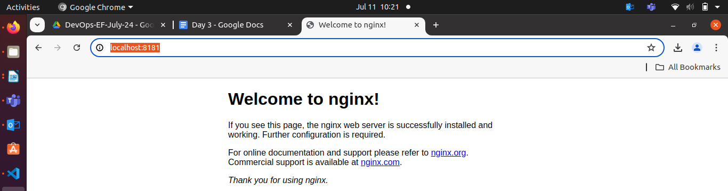

Part 2: Modifying the Container and Creating a New Image
Objective: Modify the running Nginx container to serve a custom HTML page and create a new image from this modified container.
Steps:
Access the Running Container:
docker exec -it my-nginx /bin/bash

Create a Custom HTML Page:
echo "<html><body><h1>Hello from Docker!</h1></body></html>" > /usr/share/nginx/html/index.html
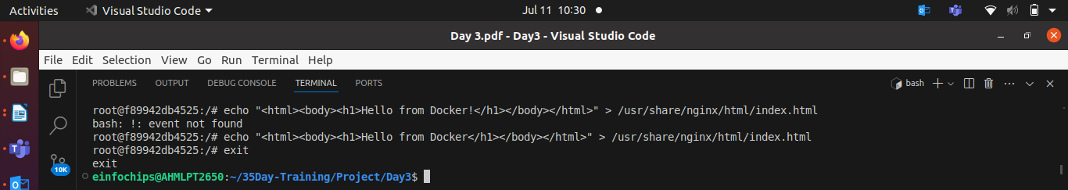

Exit the Container:
exit

Commit the Changes to Create a New Image:
docker commit my-nginx custom-nginx
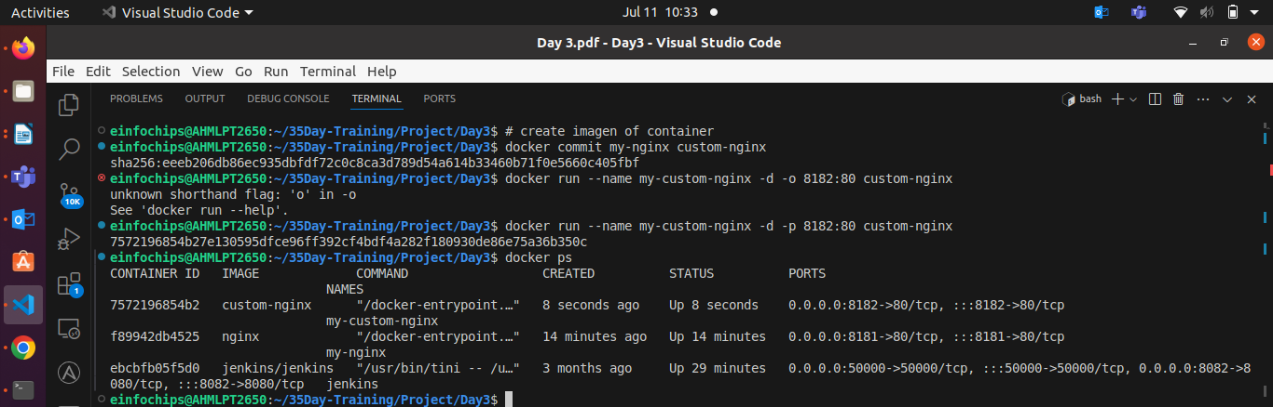
I assgin host port for user is 8182 for just craeted custom image of existing container.

Run a Container from the New Image:
docker run --name my-custom-nginx -d -p 8081:80 custom-nginx

- Verify the New Container:
  - Visit http://localhost:8081 in your browser. You should see your custom HTML page.
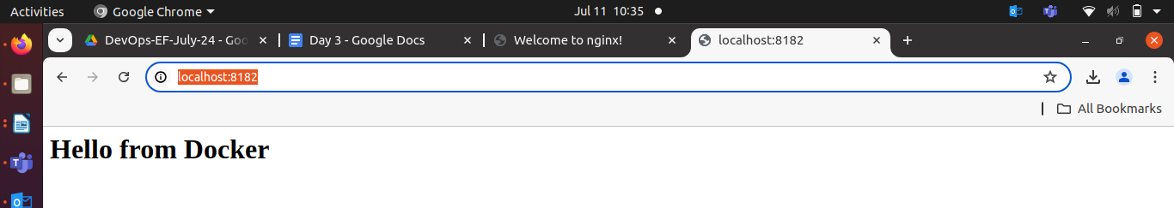

Part 3: Creating a Dockerfile to Build and Deploy a Web Application
Objective: Write a Dockerfile to create an image for a simple web application and run it as a container.
Steps:
Create a Project Directory:
mkdir my-webapp
cd my-webapp

- Create a Simple Web Application:
Create an index.html file:
<!DOCTYPE html>
<html>
<body>
<h1>Hello from My Web App!</h1>
</body>
</html>
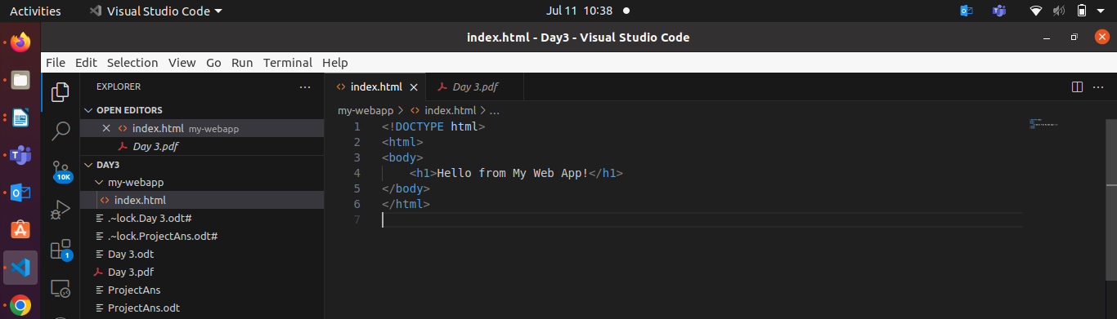
  - Save this file in the my-webapp directory.
- Write the Dockerfile:
Create a Dockerfile in the my-webapp directory with the following content:
# Use the official Nginx base image
FROM nginx:latest

# Copy the custom HTML file to the appropriate location
COPY index.html /usr/share/nginx/html/

# Expose port 80
EXPOSE 80

Build the Docker Image:
docker build -t my-webapp-image .
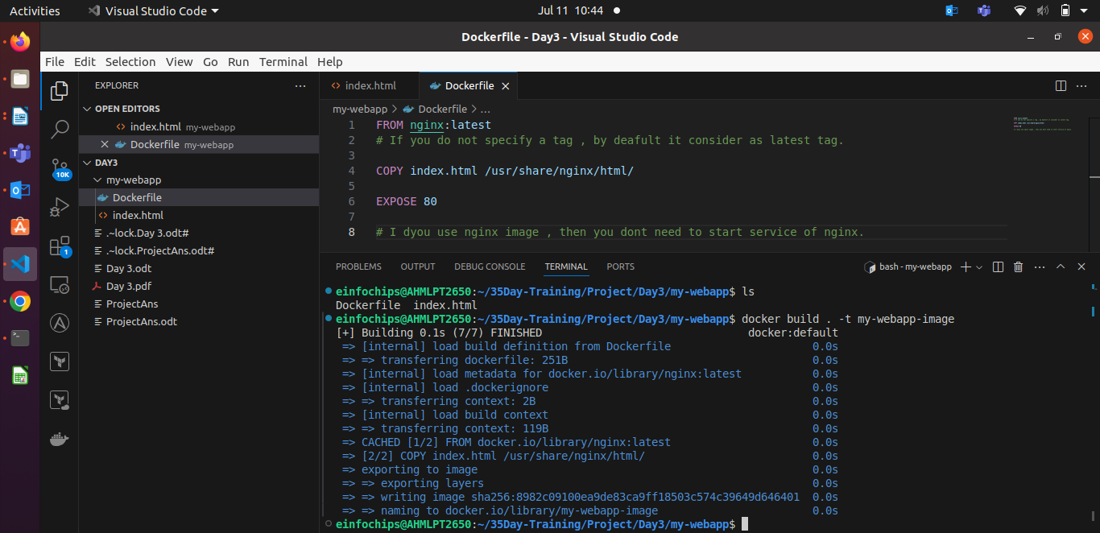

Run a Container from the Built Image:
docker run --name my-webapp-container -d -p 8082:80 my-webapp-image
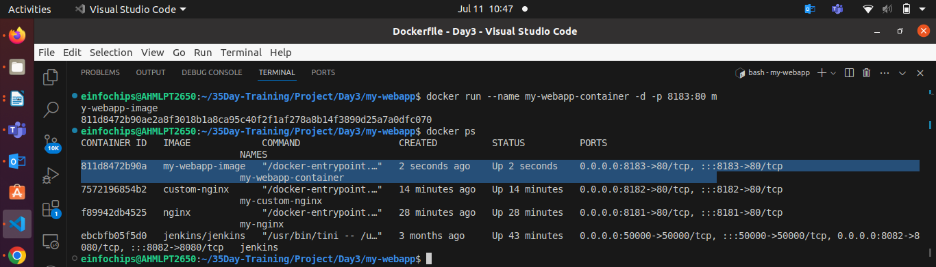

- Verify the Web Application:
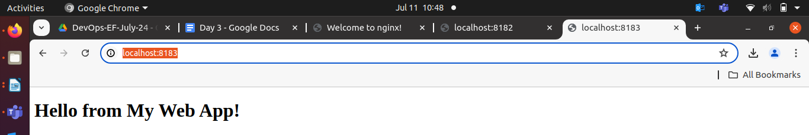
  - Visit http://localhost:8082 in your browser. You should see your custom web application.

Part 4: Cleaning Up
Objective: Remove all created containers and images to clean up your environment.
Steps:
Stop and Remove the Containers:
docker stop my-nginx my-custom-nginx my-webapp-container
docker rm my-nginx my-custom-nginx my-webapp-container

- Remove the Images:
docker rmi nginx custom-nginx my-webapp-image

Docker Project 02

Project Overview
In this advanced project, you'll build a full-stack application using Docker. The application will consist of a front-end web server (Nginx), a back-end application server (Node.js with Express), and a PostgreSQL database. You will also set up a persistent volume for the database and handle inter-container communication. This project will take more time and involve more detailed steps to ensure thorough understanding.

Part 1: Setting Up the Project Structure
Objective: Create a structured project directory with necessary configuration files.
Steps:
Create the Project Directory:
mkdir fullstack-docker-app
cd fullstack-docker-app

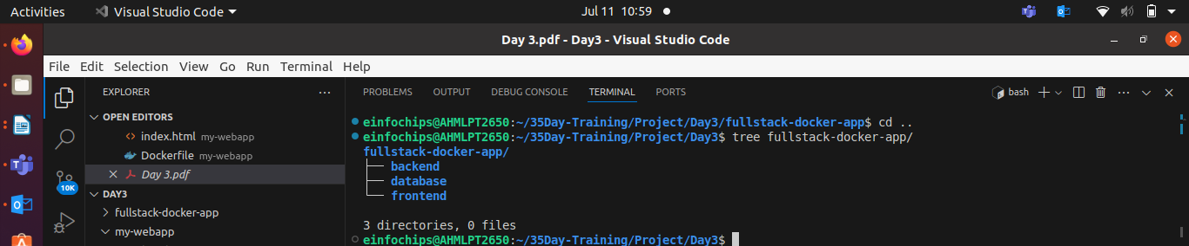
Create Subdirectories for Each Service:
mkdir frontend backend database

- Create Shared Network and Volume:
  - Docker allows communication between containers through a shared network.
docker network create fullstack-network

  - Create a volume for the PostgreSQL database.
docker volume create pgdata

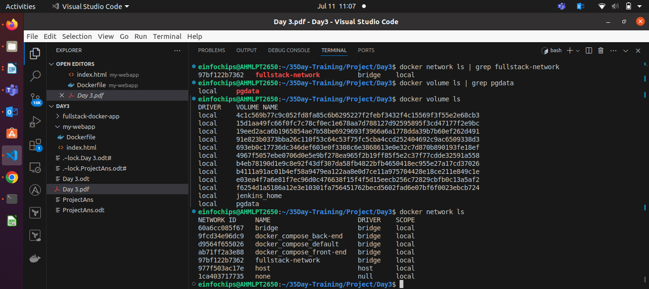
Part 2: Setting Up the Database
Objective: Set up a PostgreSQL database with Docker.
Steps:
- Create a Dockerfile for PostgreSQL:
In the database directory, create a file named Dockerfile with the following content:
FROM postgres:latest
ENV POSTGRES_USER=user
ENV POSTGRES_PASSWORD=password
ENV POSTGRES_DB=mydatabase
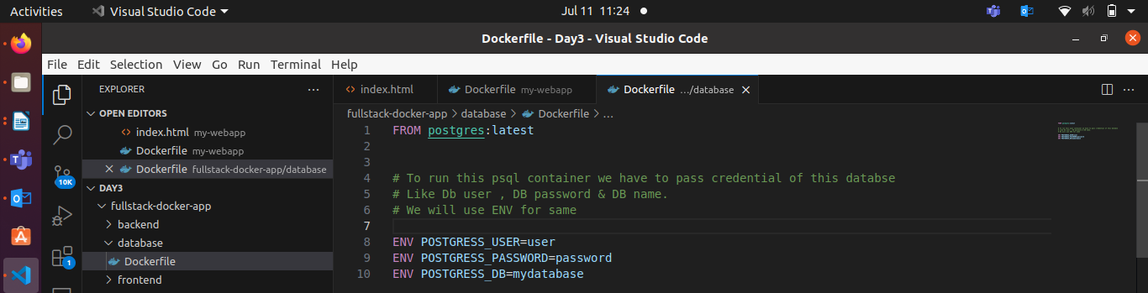

Build the PostgreSQL Image:
cd database
docker build -t my-postgres-db .
cd ..
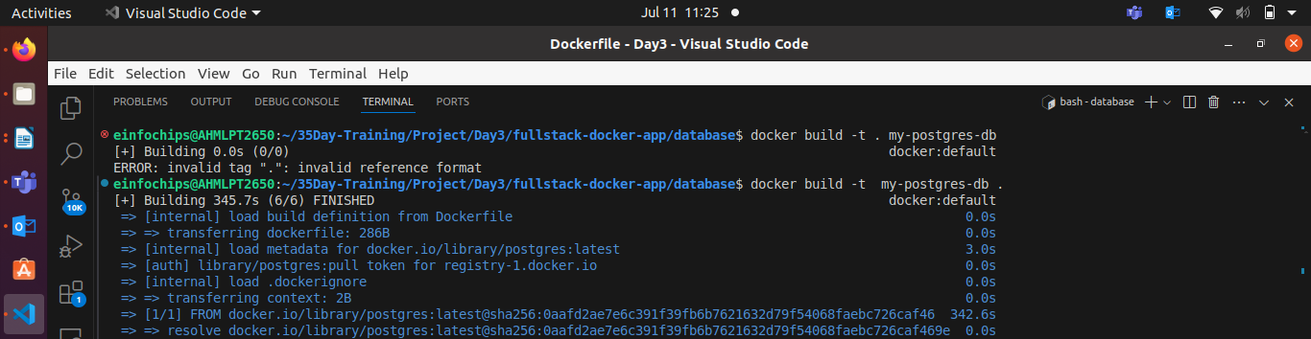

Run the PostgreSQL Container:
docker run --name postgres-container --network fullstack-network -v pgdata:/var/lib/postgresql/data -d my-postgres-db

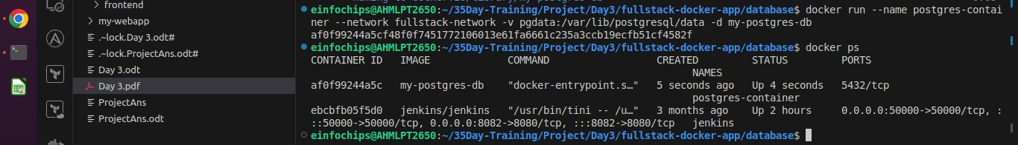
Part 3: Setting Up the Backend (Node.js with Express)
Objective: Create a Node.js application with Express and set it up with Docker.
Steps:
Initialize the Node.js Application:
cd backend
npm init -y

Install Express and pg (PostgreSQL client for Node.js):
npm install express pg

- Create the Application Code:
In the backend directory, create a file named index.js with the following content:
const express = require('express');
const { Pool } = require('pg');
const app = express();
const port = 3000;

const pool = new Pool({
user: 'user',
host: 'postgres-container',
database: 'mydatabase',
password: 'password',
port: 5432,
});

app.get('/', (req, res) => {
res.send('Hello from Node.js and Docker!');
});

app.get('/data', async (req, res) => {
const client = await pool.connect();
const result = await client.query('SELECT NOW()');
client.release();
res.send(result.rows);
});

app.listen(port, () => {
console.log(`App running on http://localhost:${port}`);
});

- Create a Dockerfile for the Backend:
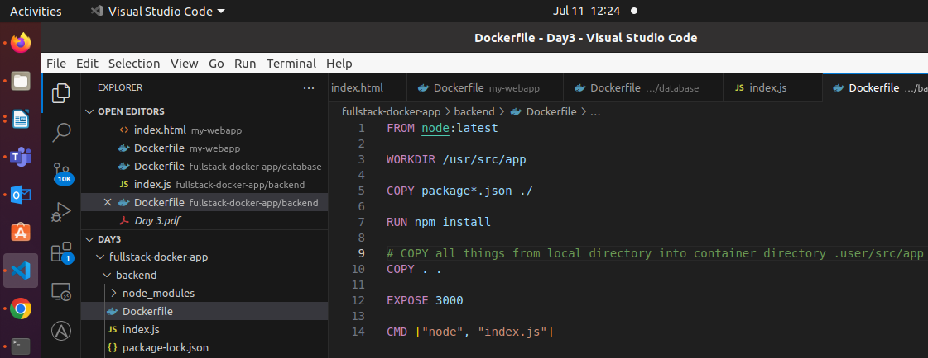
In the backend directory, create a file named Dockerfile with the following content:
FROM node:latest

WORKDIR /usr/src/app

COPY package*.json ./
RUN npm install

COPY . .

EXPOSE 3000
CMD ["node", "index.js"]

Build the Backend Image:
docker build -t my-node-app .
cd ..

Run the Backend Container:
docker run --name backend-container --network fullstack-network -d my-node-app
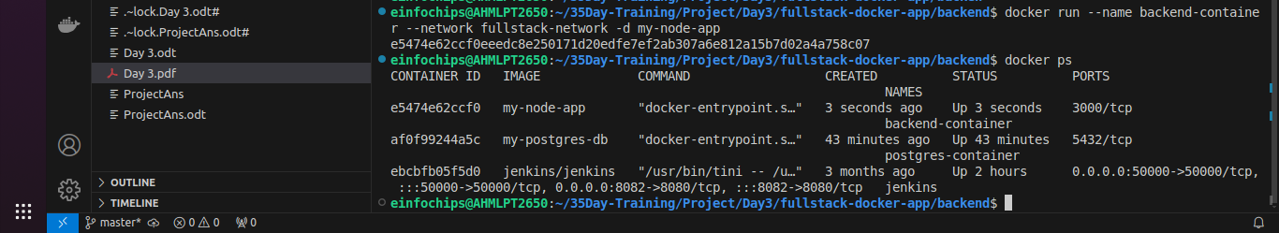

Part 4: Setting Up the Frontend (Nginx)
Objective: Create a simple static front-end and set it up with Docker.
Steps:
- Create a Simple HTML Page:
In the frontend directory, create a file named index.html with the following content:
<!DOCTYPE html>
<html>
<body>
<h1>Hello from Nginx and Docker!</h1>
<p>This is a simple static front-end served by Nginx.</p>
</body>
</html>

- Create a Dockerfile for the Frontend:
In the frontend directory, create a file named Dockerfile with the following content:
FROM nginx:latest
COPY index.html /usr/share/nginx/html/index.html

Build the Frontend Image:
cd frontend
docker build -t my-nginx-app .
cd ..

Run the Frontend Container:
docker run --name frontend-container --network fullstack-network -p 8080:80 -d my-nginx-app
In my case port is 8184
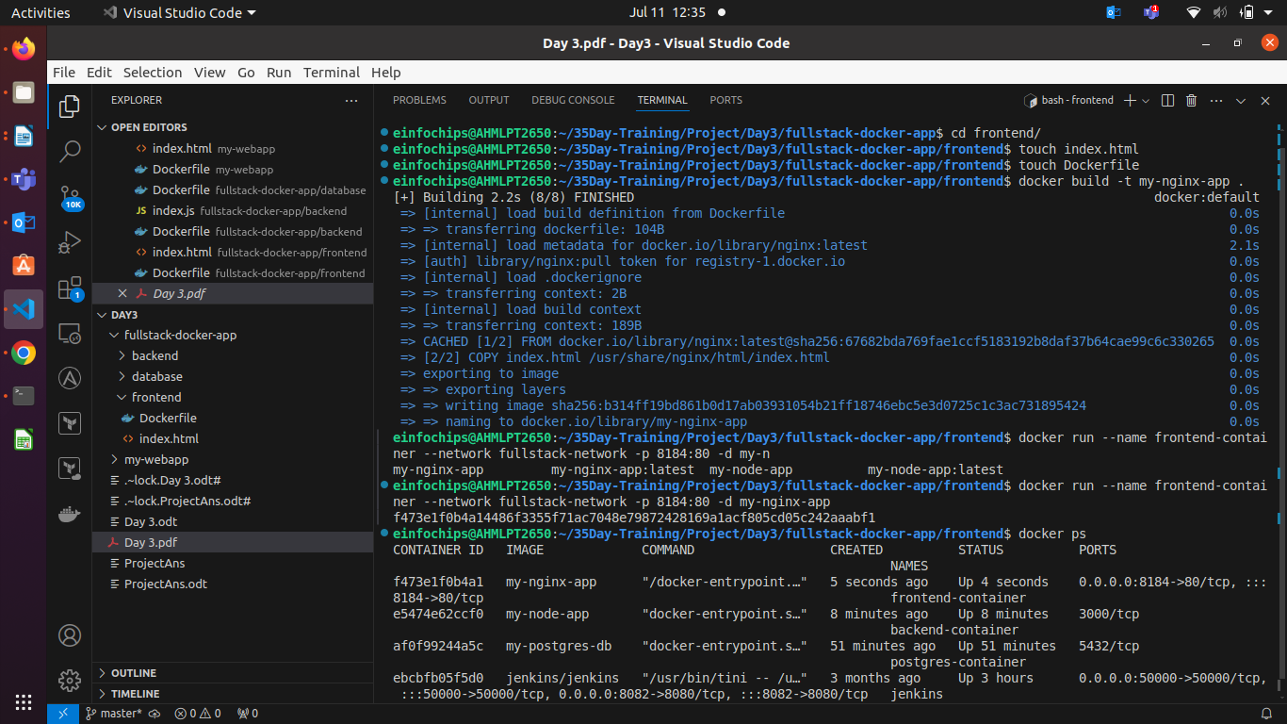

Part 5: Connecting the Backend and Database
Objective: Ensure the backend can communicate with the database and handle data requests.
Steps:
- Update Backend Code to Fetch Data from PostgreSQL:
  - Ensure that the index.js code in the backend handles /data endpoint correctly as written above.
- Verify Backend Communication:
Access the backend container:
docker exec -it backend-container /bin/bash

Test the connection to the database using psql:
apt-get update && apt-get install -y postgresql-client
psql -h postgres-container -U user -d mydatabase -c "SELECT NOW();"
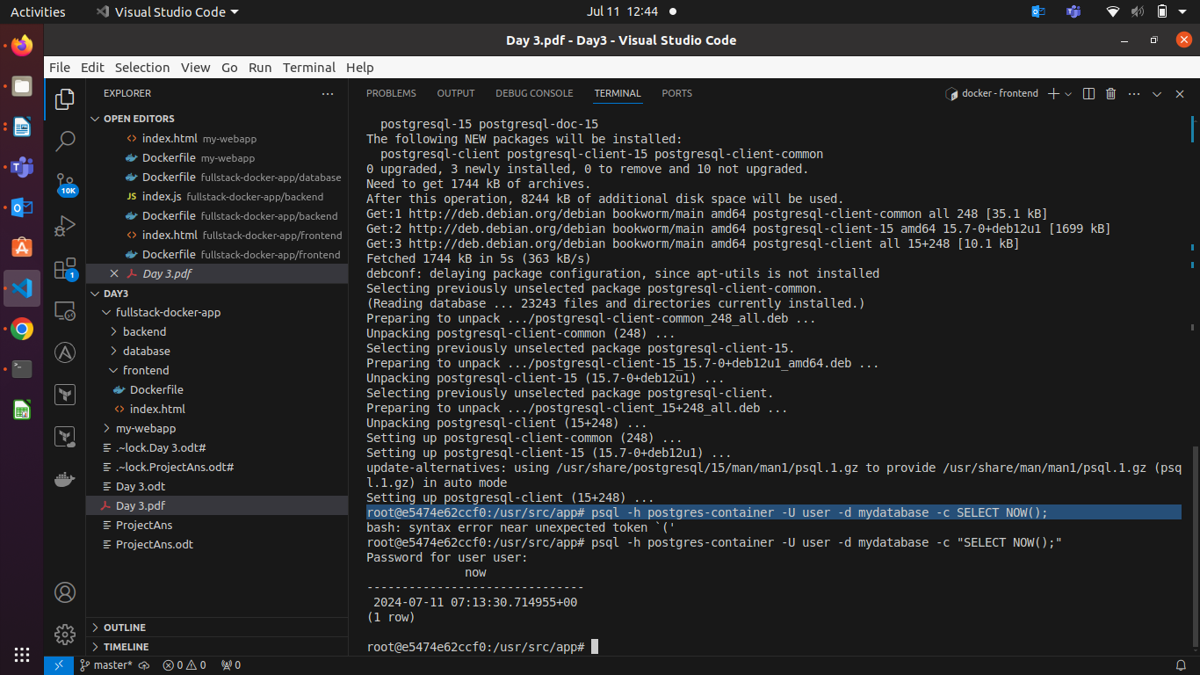

Exit the container:
exit

- Test the Backend API:
  - Visit http://localhost:3000 to see the basic message.
  - Visit http://localhost:3000/data to see the current date and time fetched from PostgreSQL.

Part 6: Final Integration and Testing
Objective: Ensure all components are working together and verify the full-stack application.
Steps:
- Access the Frontend:
  - Visit http://localhost:8080 in your browser. You should see the Nginx welcome page with the custom HTML.
- Verify Full Integration:
Update the index.html to include a link to the backend:
<!DOCTYPE html>
<html>
<body>
<h1>Hello from Nginx and Docker!</h1>
<p>This is a simple static front-end served by Nginx.</p>
<a href="http://localhost:3000/data">Fetch Data from Backend</a>
</body>
</html>

Rebuild and Run the Updated Frontend Container:
cd frontend
docker build -t my-nginx-app .
docker stop frontend-container
docker rm frontend-container
docker run --name frontend-container --network fullstack-network -p 8080:80 -d my-nginx-app
cd ..

- Final Verification:
  - Visit http://localhost:8080 and click the link to fetch data from the backend.
Part 7: Cleaning Up
Objective: Remove all created containers, images, networks, and volumes to clean up your environment.
Steps:
Stop and Remove the Containers:
docker stop frontend-container backend-container postgres-container
docker rm frontend-container backend-container postgres-container

Remove the Images:
docker rmi my-nginx-app my-node-app my-postgres-db

Remove the Network and Volume:
docker network rm fullstack-network
docker volume rm pgdata

